OPERATION & MAINTENANCE MANUAL FOR ELECTO-HYDRAULIC DOCK LEVELER

DESIGNED, DEVELOPED & MARKETED
BY



G-BLOCK, 1ST FLOOR, THERMAX CHOWK
MIDC, ABOVE RENAULT SHOWROOM
CHINCHWAD, PUNE-411019

TEL.NO: - +912066304033
EMAIL: -sales@nihva.com
www.nihva.com

INTRODUCTION

The hydraulic Dock Leveler is the result of many years’ experience in materials handling equipment design & manufacturing. “NIHVA” offers the best possible factor of safety with simple, easy to use controls. The high quality of manufacture gives a robust construction and many years of useful life. Each lip and platform movement can be individually controlled by push button.
The dock leveler can be set at any position. During loading, the Dock Leveler is in floating mode i.e. it follows the up/down movements of the vehicle deck. Even with lopsided vehicles, the Dock leveler lip will remain in contact, and toe-traps are avoided by the tilt built into the Dock Leveler.
The whole platform is designed to flex laterally adequately to adapt to sideways tilted vehicles. The leveler always seals perfectly to the lorry bed.

INDEX

- DISPATCH & UNLOADING
- ORDERING OF SPARES
- EMERGENCY CONTACT DETAILS
- SPECIFICATIONS OF DOCK LEVELER
- PRE-OPERATING INSTRUCTIONS
- OPERATING INSTRUCTIONS
- ROUTINE MAINTENANCE
- PARTS LIST
- GA DRAWING OF DOCK LEVELER
- HYDRAULIC CIRCUIT DIAGRAM
- ELECTRICAL CONNECTINS DIAGRAM
- TROUBLESHOOTING OF DOCK LEVELER

- DESPATCH & UNLOADING

- Loading, for dispatch, will be our responsibility. On receipt of the Dock-leveler at site, please check and ensure that there is no physical damage to the equipment.
- While unloading the equipment from the transporting vehicle, please ensure to use slings with rated capacity higher than the gross weight of the Stationary lift in packed condition.
- Slings MUST be hooked ONLY at specified positions. These positions are indicated and marked with a figure of ‘HOOK’. Improper sling position or improper slinging could cause damage to the equipment & serious accidents.

- ORDERING OF SPARES

When ordering for spare, please specify the following in your Purchase Order.

- Equipment Name
- Model Number
- Equipment Serial No.
- Part name / Description
- Part Number
- Quantity required
- Delivery period / time
- Mode of dispatch

This would avoid ambiguity and help us serve you better.

- EMERGENCY CONTACT DETAILS: -

        - Service - 9168938333
        - Projects- 8551008333

- SPECIFICATIONS OF DOCK LEVELER:

- Type of dock leveler- Pit Mounted Hydraulic dock leveler
- Deck operation – Hydraulic cylinder operated
- Lip operation - Hydraulic cylinder operated
- Operation control – by push buttons
- Dock leveler Size- As per GA drawing
- Dock leveler capacity- As per GA drawing
- Lip Size – As per GA drawing
- Maximum slope achieved- 8 to 10%
- Recommended Loading platform height from road level – 1200 mm
- Pit Size – As per GA Drawing
- Powerpack – NIHVA Standard DL
- Control Panel- NIHVA Standard DL

- PRE – OPERATING INSTRUCTIONS: -

  - The operator / owner shall read and be familiar with the Owner’s manual, especially the Operating and Maintenance Instruction.
  - In the event of a malfunction, the operator shall consult the Owner’s Manual and contact NIHVA.
  - Any repair or modifications by an unqualified technician will void the warranty.
  - Ensure Hydraulic Oil in the power pack.
  - Ensure Motor connection and proper earthing.
  - Ensure joint leakage.
  - Ensure proper location of platform and lip.

- OPERATIONAL SAFETY WARNING
- Do not enter the pit area below the dock leveler.
- BEFORE BEGINNING ANY SERVICE PROCEDURES: – Follow all lockout / tagout procedures.
- Never operate a broken or damaged dock leveler. Have repairs done immediately by a qualified service technician.
- Always secure and center loads on the forklifts. Loose or un balanced loads are dangerous.
- The upper hinge point is a hazardous pinch point. Do not use fingers or hands to remove foreign materials.
- Post safety warnings and barricade working area at dock level and at ground level to prevent unauthorized use of the leveler during maintenance/service.
- Never leave the dock leveler unattended in the raised position.
- Always make sure that the lip is seated inside the lock after putting the dock in the parked position.
- Never leave loads sitting on the dock leveler.
- Do not attempt to raise the dock leveler if someone is standing on it.
- Do not use the dock leveler if the lip’s full width is not fully supported by the vehicle load bed.
- Do not operate the dock leveler beyond its rated capacity.
- Do not drive or walk onto the truck until it is parked against the dock bumpers and the wheels are chocked, or the vehicle restraint has been fully engaged.
- Never attempt to lift or hold the lip out by hand. Serious personal injury could occur.
- Never remove the wheel chocks until loading/ unloading is finished and the truck driver has been given permission to depart.
- Do not ground welding equipment to any electrical components.
- Do not attach welder as ground to leveler platform when welding on base frame assembly. Attach welder ground to base frame assembly only.
- Always keep the work area clean and free of litter.
- Always clean all side openings of dirt and debris.
- Always clean all dirt and debris from the lip hinge.
- Always clean up dry and liquid spills immediately after they occur.
- Always maintain proper lighting in the work area.
- Do not operate the dock equipment until the transport vehicle is parked against the dock bumpers.
- Always park the dock equipment after use.
- Conduct routine inspections and maintenance. Failure to do so could cause equipment damage and or personal injury

- OPERATING INSTRUCTIONS: -

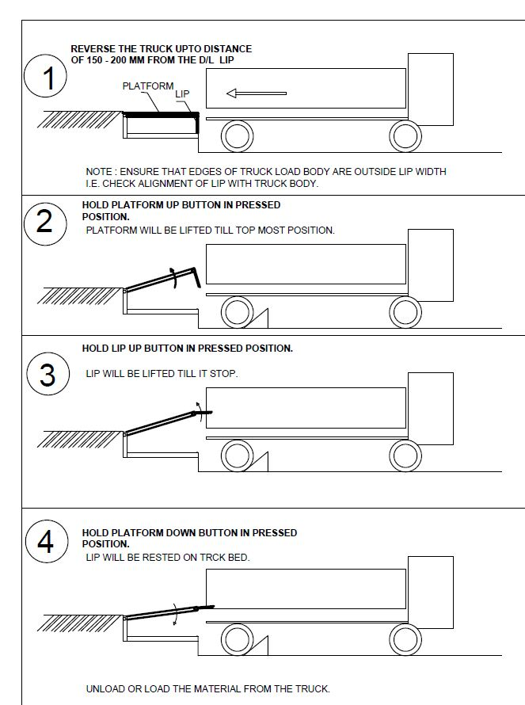
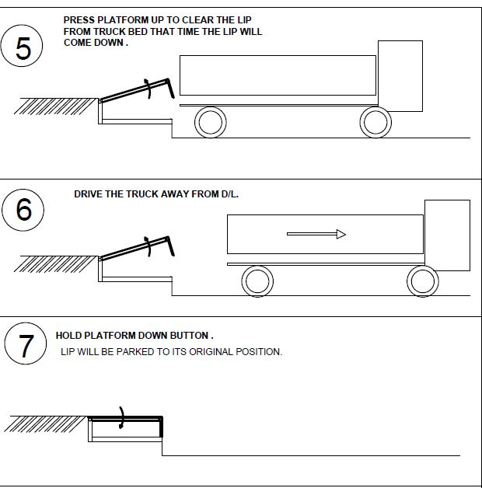

- ROUTINE MAINTENANCE

These recommendations are applicable to the Dock Leveler considering average daily usage of 15 to 20 times. If it is used more frequently, the same time intervals for the maintenance should be adjusted accordingly.

DAILY:
- Check Hydraulic pipe lines for leak proof working.
- Check electrical connections for their proper working.

MONTHLY:
- Grease the hinge pins at bottom frame and top plate joint and extension lip plate hinge joint.
- Grease the main Jack Cylinder and Lip Jack Cylinder, Top and Bottom pins if some frictional sound hears.
- Change Hydraulic Oil (servo 68) viscosity from hydraulic expert & change if required.

PARTS LIST:

SR NO | ITEM DESCRIPTION
1 | DECK
2 | DECK CYLINDER
3 | LIP PLATE
4 | LIP CYLINDER
5 | BOTTOM FRAME
6 | POWERPACK
7 | CONTROL PANEL
8 | BUMPER
9 | HYDRAULIC HOSES
10 | HYDRAULIC FITTINGS
11 | MAINTENANCE STOPPER

DOCK LEVELER GA DRAWING:

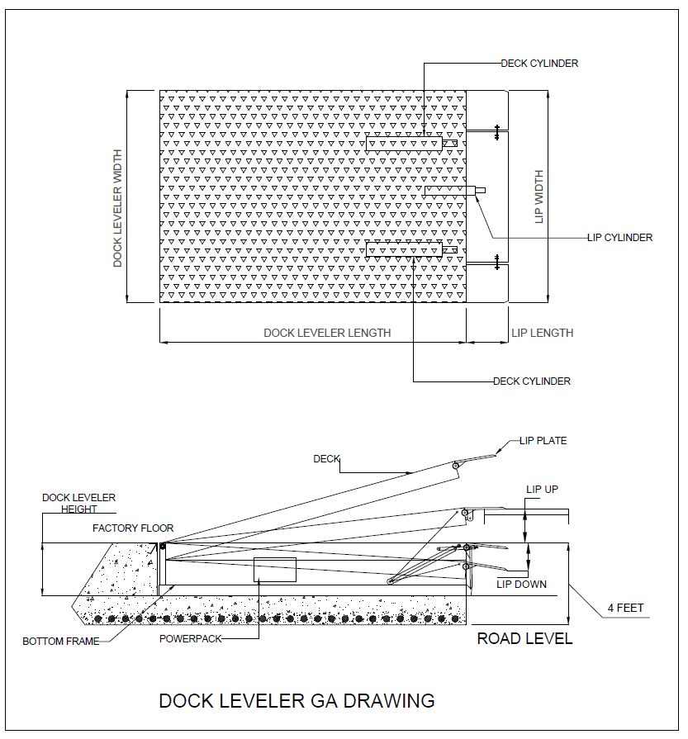

DOCK LEVELER HYDRAULIC CIRCUIT DIAGRAM:

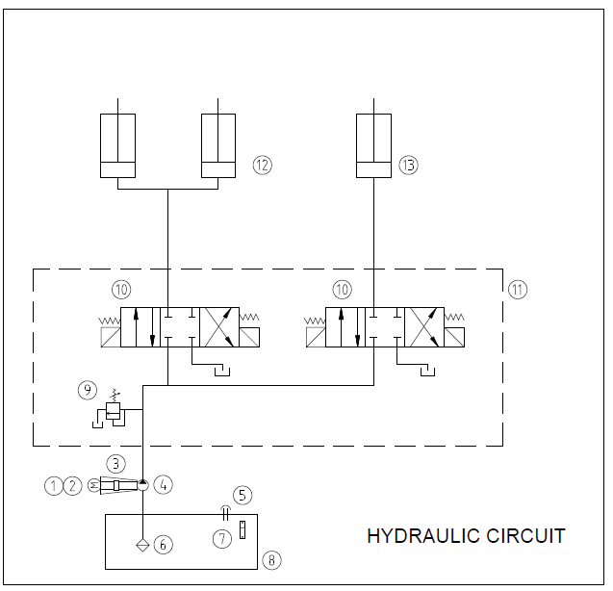

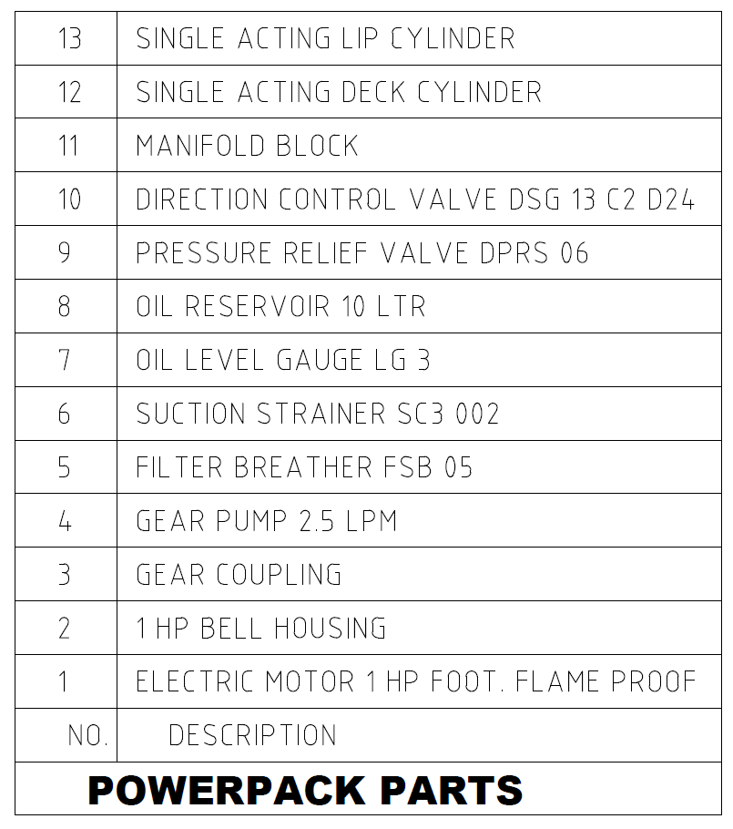

DOCK LEVELER ELECTRICAL CIRCUIT DIAGRAM:

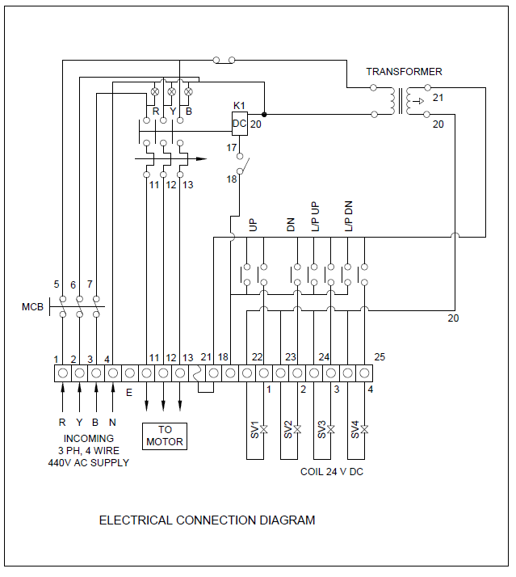

- TROUBLESHOOTING OF DOCK LEVELER-

PROBLEM | PROBLEM CAUSE
Deck will not raise when PUSH button is operated. Motor DOES start and run. | - Foreign materials may be lodged between the side of the deck and the pit wall.  - Equipment or goods may be parked on the dock leveler  - Low hydraulic oil in power unit.  - Incorrect motor rotation (three phase power supply only).  - Relief valve is bypassing
Deck will not begin to raise immediately when motor begins to run. Usually occurs only after the deck cylinder hose has been replaced with a new hose that was not prefilled with oil. | Air is trapped in the deck lifting cylinder. Bleed.
Deck will not raise when push button is operated. Motor does not attempt to run; no sound is heard from motor/ powerpack/control box | - No power supply to control box.  - Thermal overload tripped open.  - Faulty control box component (e.g. fuse, touch button, contactor, transformer)
Deck will not raise when touch button is operated. Motor attempts to run, but power supply breaker switch trips to off position | Power supply circuit is overloaded by other equipment or components being used on a branch circuit controlled by the same breaker switch. The power supply line circuit must be upgraded to meet the requirements of the power unit
Lip does not extend fully. Oil level in reservoir is not low. | - Lip plate bent causing hinge to bind.  - Foreign material lodged in the lip hinge area.  - Relief valve is bypassing.
Deck raises partially and stops. Motor continues to run and power unit makes more noise than normal | Oil level in reservoir is low.
Deck raises more slowly than normal and level in reservoir is normal | - Deck or damaged skirts dragging on side of pit.  - Faulty powerpack
- NOTES-

……………………………………………………………………………………………………………………………………………………………………………………………………………………………….……………………………………………………………………………………………………………………………………………………………………………………………………………………………….
……………………………………………………………………………………………………………………………………………………………………………………………………………………………….
……………………………………………………………………………………………………………………………………………………………………………………………………………………………….
……………………………………………………………………………………………………………………………………………………………………………………………………………………………….
……………………………………………………………………………………………………………………………………………………………………………………………………………………………….
……………………………………………………………………………………………………………………………………………………………………………………………………………………………….
……………………………………………………………………………………………………………………………………………………………………………………………………………………………….
……………………………………………………………………………………………………………………………………………………………………………………………………………………………….
……………………………………………………………………………………………………………………………………………………………………………………………………………………………….
……………………………………………………………………………………………………………………………………………………………………………………………………………………………….
……………………………………………………………………………………………………………………………………………………………………………………………………………………………….

